Arrow represents the amount of motion.

Swirling hurricane and tornado.

Suppose we have volume of space and this volume can be any shape and size.

Consider the volume of certain size and is kept in the path of the particles moving in certain direction. There may be three cases.

1. If sum of particles entering equals coming out of the volume then, the volume is neither absorbing and generating particles.
2. If entering is greater than coming out, absorbing particles.
3. If coming out particles is greater than entering in, then generating volume.

The amount by which the amount of space is generating or absorbing particles depends upon the difference between the sum of the arrows entering and coming out of the volume.

If an arrow is passing through the surface of the volume at an angle, then it can be thought of the combination of an arrow that is perpendicular to the surface and parallel to the surface.

When arrow is strike at an angle to the surface, we care only about the portion of arrow perpendicular to the surface.

**At each point in space, the rate at which particles are being generated per unit volume is what we refer as divergence of the vector field at this point in space.**

e.g. 4 particles enter and 10 exits at the same time in and from the unit volume, then 6 particles are generated per unit volume which we call divergence.

**Particles swirling**, simply is defined on the surface.

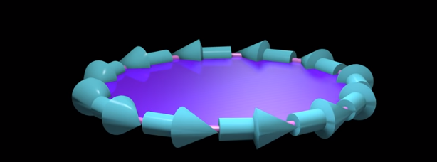

Here, we consider a surface which may be any shape and size and this surface is surrounded by a loop. And we care only the arrow on the loop.

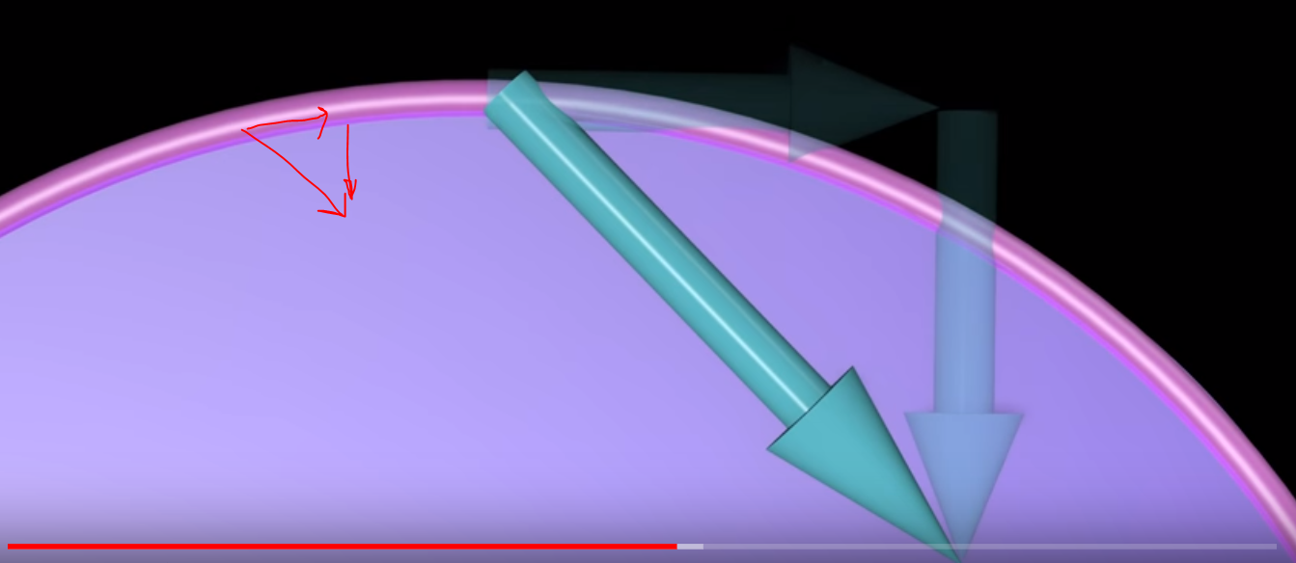

Here, we only care of the portion of arrow that is parallel to the loop path.

We don’t care about the particle moving perpendicular to the loop’s path because this means the particle is not swirling around the loop so this arrow doesn’t count.

If we add the lengths of all the arrows around the loop together, their sum indicates how much the particles are swirling around the loop.

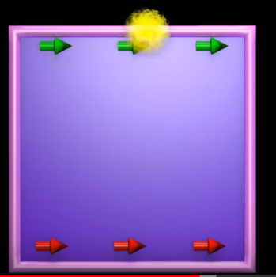

Suppose we have a point that travels around the loop. Some arrows will be pointing in the same direction and some in opposite direction.

If sums of the arrows lengths are added together equals to zero, so we say that particles are not swirling around the loop.

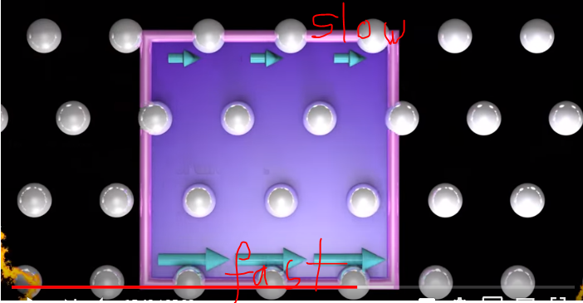

In upper figure upper particles are denoted by red arrow in clockwise direction an bottom arrow are in counterclockwise represented by green arrow.

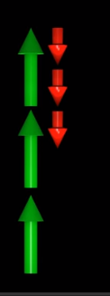

Certain value is obtained so can say that particles are swirling.

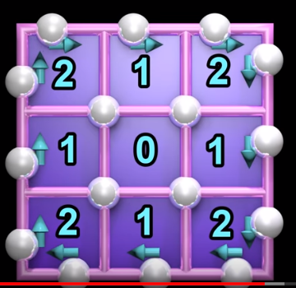

Lets divide the big surfaces into smaller surfaces. The total swirling around the big surface equals to the sum of the swirling around each of these smaller surface.

This is true no matter if the particles are moving inside the loop or not.

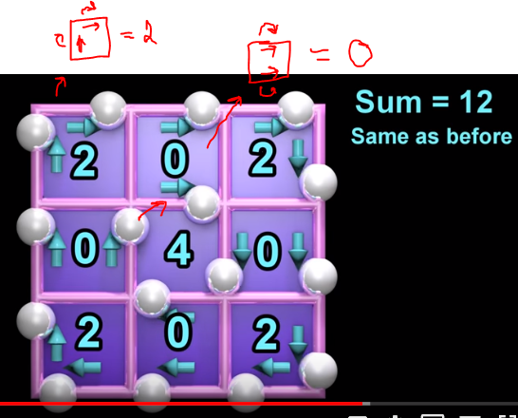

Another example:

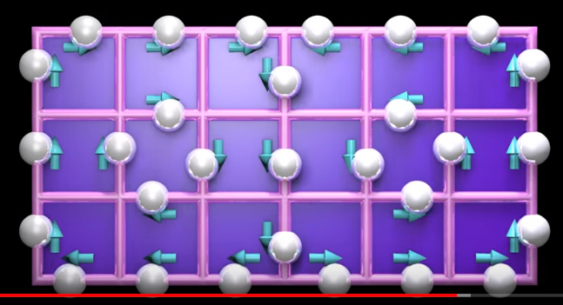

Swirling around the larger surface is zero.

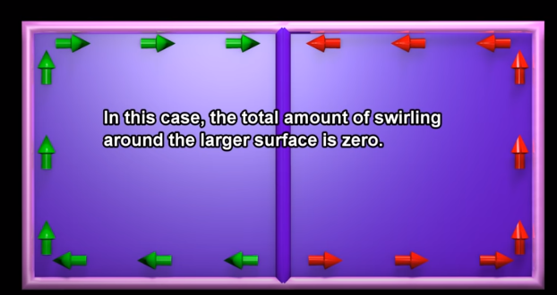

**At each pint in space, the rate at which particles are swirling around the surface per unit area what we call curl of the vector field at the point in space.**

At each point in space the amount of curl can be represented by the length of an arrow that is perpendicular to the surface.

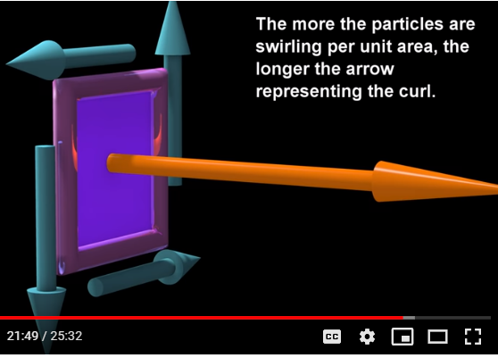

If particles swirling changes its direction then the arrow representing the direction of curl will also change.

If no net swirling, then zero curl.

The surface at the point in space can be oriented in all three dimensions. Therefore, the curl of this vector field at each point in space can have components in all three dimensions.